Fine Art Workshop

*Your Journey to Your Creativity and Artwork Goals*  
3-Day Workshop with Ken ElliottAt the Cincinnati Art Club  
Location: 1021 Parkside Pl. Cincinnati, Ohio 45202

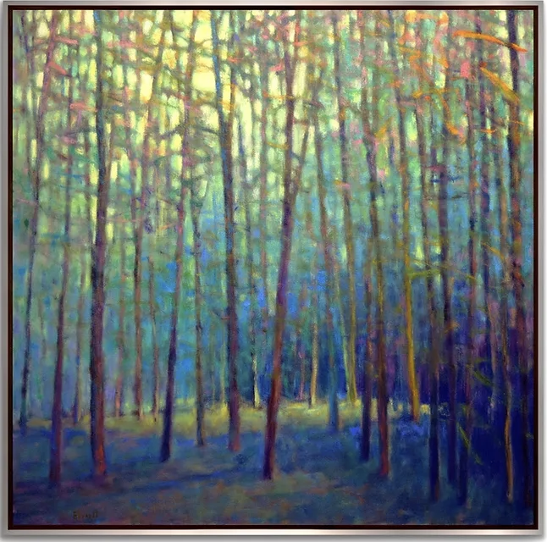May 2-4, Friday - Sunday, 9:30-4pm

**Open to artists at all skill levels and media**

An indoor, 3-day workshop

Limited to 10 artists, $395 Non-members

$375 Club-members

Additional information and/or to [sign up online](https://www.eventbrite.com/e/your-journey-to-your-creativity-and-artwork-goals-with-ken-elliott-tickets-1022736812337?aff=oddtdtcreator)

NOTE: the early deadline to register: **April 9**

**The public is invited to a “Meet and Greet”**

**Thursday, May 1 (cost $10.)**

**at the Cincinnati Art Club, 6:30-8:30 pm. Ken Elliott will**

**introduce his book “Manifesting 1,2,3” and will share**

**insights to success such as getting into a gallery, pricing your**

**work, and all the other challenges we artists confront...**

[**For more info:**](https://www.eventbrite.com/e/an-evening-with-ken-elliott-tickets-1092655916259?aff=oddtdtcreator)

Long links: for the workshop: [**https://www.eventbrite.com/e/your-journey-to-your-creativity-and-artwork-goals-with-ken-elliott-tickets-1022736812337?aff=oddtdtcreator**](https://www.eventbrite.com/e/your-journey-to-your-creativity-and-artwork-goals-with-ken-elliott-tickets-1022736812337?aff=oddtdtcreator)

For the Meet and Greet: [**https://www.eventbrite.com/e/an-evening-with-ken-elliott-tickets-1092655916259?aff=oddtdtcreator**](https://www.eventbrite.com/e/an-evening-with-ken-elliott-tickets-1092655916259?aff=oddtdtcreator)

**The Workshop**

**Ken will discuss strategies for creating better artworks with a variety of common and creative tools.** The workshop will focus on concepts for making better starts, compelling artworks, going to new places in your work, and how to make fine art. They will use informative videos and pass on strategies, handed down from the very best teachers.

**Ken will demonstrate painting using oil and pastels, if requested.** In addition to making art works, Ken will expand upon some of the topics from the “Meet and Greet” about the artist’s business and promotion, and other necessary tools for success in the marketplace.

**​There will be serious discussions, laughs, and your questions with more continuation after class hours.** We will all come away with new tools to take your art to the next level. Ample time will be provided for feedback from Ken on your start-ups, works in progress and finished pieces.

Ken Elliott’s Bio*Ken comes from a background of working in the art gallery and ancillary art businesses for over 40 years.* ***As an artist for 25 of those years, he can speak about the business and creative aspects of being a professional artist. He studied with Wolf Kahn at the Santa Fe Art Institute Master Class program, coming away with enough information for a lifetime. For decades he has been associated with wonderful and successful artists. As a former gallery dealer, he has a great deal of experience and knowledge about past and present artists and their reasons for success. Ken Elliott has much to offer to the beginning and professional artist.***

Questions? Call 440-376-7769 or email: [workshops@cincinnatiartclub.com](mailto:workshops@cincinnatiartclub.com)