Making it Fine Art Workshop: *Moving to the Next Level*  
3-Day Workshop with Ken ElliottCastle Rock, Colorado  
Location: 574 Wenlock Ct. Castle Rock, CO (Denver Metro)

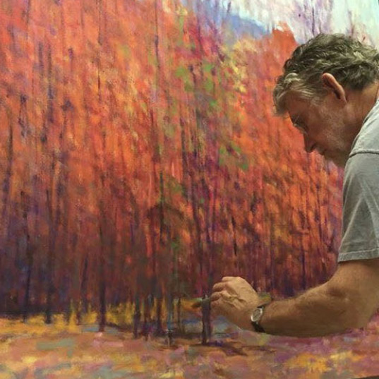

Workshops, **2025**Friday - Sunday, 9-4pm

Sat. evening after break, 4:30 -7, Photoshop Tools and discussions.

**Open to artists at all skill levels and media**

An indoor, 3 - day workshop

Limited to 5 artists, $590.

Sign up online: [www.kenelliott.com](http://www.kenelliott.com/)

Contact Ken: 303-995-1611

**Ken will discuss strategies for creating better artworks with a variety of common and creative tools.** The workshop will focus on concepts for making better starts, compelling artworks, going to new places in your work, and how to make fine art. They will use informative videos and pass on strategies, some not the literature, but handed down from the very best teachers.

**Together, we will be going deeper into the how-to of making more appealing artworks with a variety of ideas and tools. After the day's sessions, the group is invited to further discussions and dinner.** After the Sunday session, Ken will present Photoshop techniques for taking your works to the next level and creating better pathways for finishing your artworks. You will be given a simplified Photoshop guide and have access to a large photo file of over 2000 inspiring artworks.

**Ken will demonstrate painting using oil and pastels, if requested.** In addition to making art works, Ken will talk about business and promotion, necessary tools for success in the marketplace.

**There will be serious discussions, laughs, and your questions with more continuing after class hours.** We will all come away with new tools to take your art to the next level. Ample time will be given to live problem solving, daily critiques and creative options.

Supply list follows on the next page

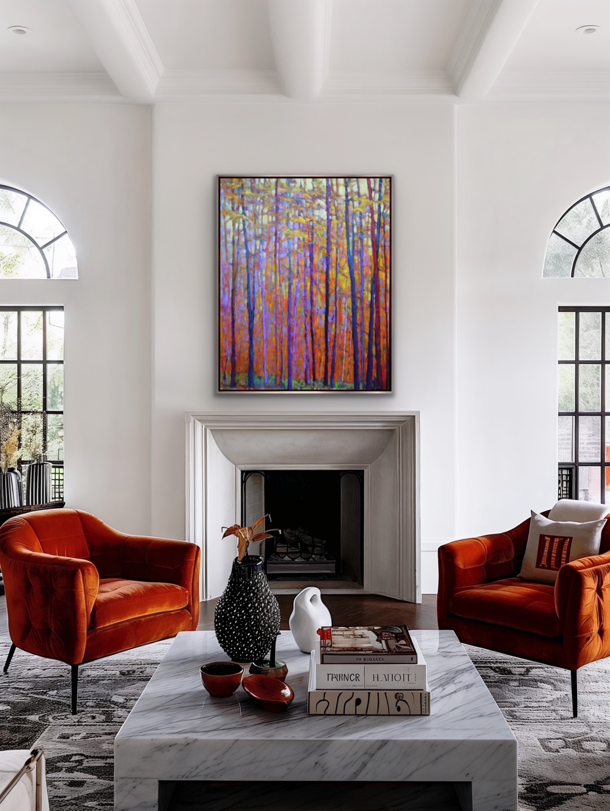

Autumn Coming Through, oil on canvas 50 x 40 inches

For the Workshop / Supply List:

There will be a lot of conversation about the mental aspects of making good art by design and experiment. The mental aspect is the quickest way to get the breakthroughs to the next big success in your art.

Write out the things you want to get from this class. I will be asking for your answer and will make that a focus.

You are invited to bring whatever you wish to paint with and work on. Bring works to

start, works in progress, and finished works to evaluate. Let’s take a fresh look at those – how you got there and how to go further. You won’t need many images, just a few to begin with.

We won’t be pushing to make completed works during this short time. Rather, we will be looking at making good starts and strategies for going beyond your comfort level.

**Art supplies:**  Easel, paints, brushes, palette knives if you choose, and minimal supplies and

accessories that you typically paint with. Don’t overload yourself. We can share.

One sheet of any paper, copy paper at 8 1/2 x 11 will do fine, along with any kind of pencil in graphite or pastel, charcoal stick etc. We will be doing one abstract drawing exercise and it will be useful to have something to draw with that is more expressive than a pencil.

Canvas (large is good: 30 x30 canvas, 30 x 40, 36 x 36 etc.) or reasonably large paper for acrylic studies or pastels. Bring the accessories you paint and draw with. If you are coming in from out of town, let me know about canvases you would need and if an easel is required.

Come with your good humor and expect to let go and have fun in a new playground.

We will learn by being open, uncritical (at least for now), and adaptable. After all, we are trying to go beyond what we are already doing.

 Thank you,

Ken

303-995-1611    [kencelliott@gmail.com](mailto:kencelliott@gmail.com)    [www.kenelliott.com](http://www.kenelliott.com/)